Design web

We now have all of the components to do more thorough designs. The design process is key within permaculture, to facilitate change and turn our ideas into reality. The design web is a framework created specifically for people based designs. It is one interpretation of the design process. This is the process we will focus on although it is not the only way of approaching permaculture designs.
It can be used for a wide variety of designs, from our own personal health to our family life, from community groups to schools, from healthcare systems to international development projects. Whoever we are designing for is ‘the client’ or ‘clients’. This may be ourselves, a family, group or organisation.
The web has 12 anchor points, each focusing on a different area to build up a detailed, holistic picture of where we want to go and how we are going to get there. The questions given here are general and open ended; they can be adapted to fit whatever you are designing.

Anchor points

3.8 design web symbols
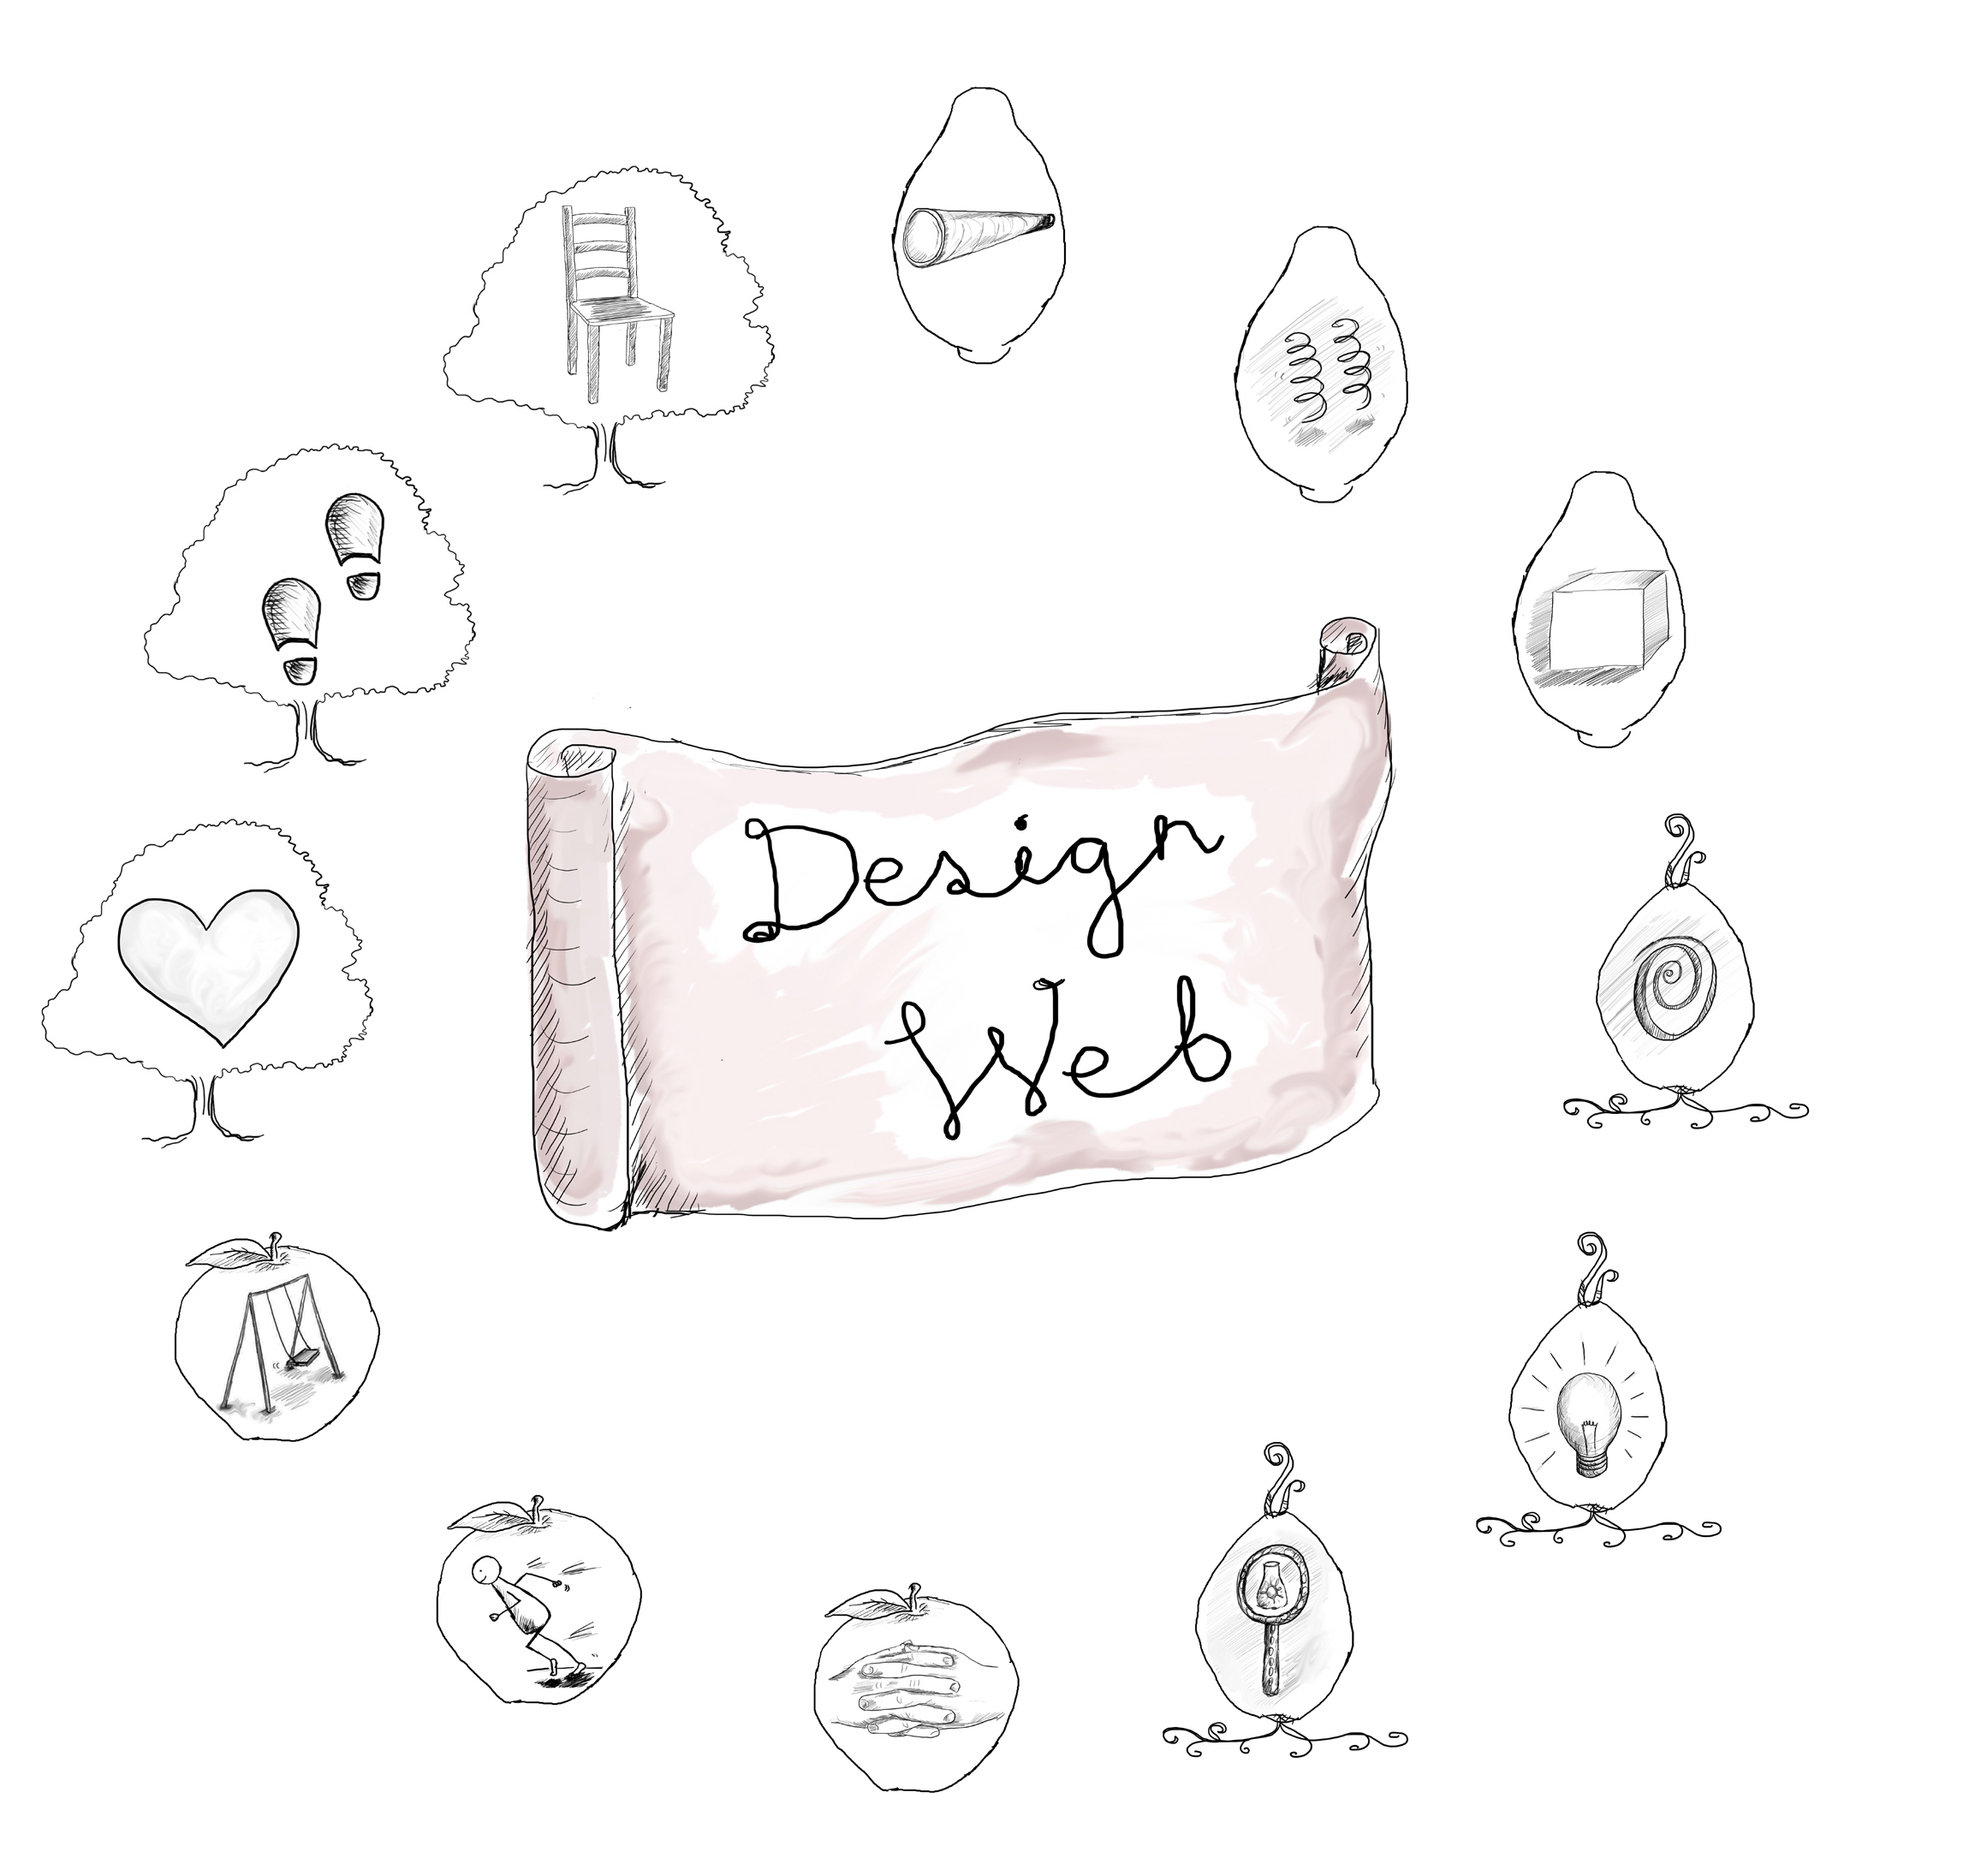
Vision – allow yourself to dream and create goals
Helps – identify the things that are going to help
Limits – identify the things that might block your path or keep it small or slow it down
Patterns – identify the helpful and unhelpful patterns
Ideas – gather inspirations

Action – make a plan for getting things done
Momentum – how to keep going

Appreciation – focus on things to be thankful for
Pause – incorporate times of rest and rejuvenation
Principles – look through the lens of each one

Integration – bring it all together

Reflection – evaluate progress

Vision - allow yourself to dream and create goals
What is my ideal?
What are the abundances I would like to create in my life?
What are my wildest dreams?

Helps – identify the things that are going to help
What are my motivations for changing?
What resources do I have within me?
What external resources are available?

Limits – identify what blocks the path, what might keep it small or slow it down
What’s holding me back?
What are my limiting factors?
Why would I not want to change?
What concerns do I have?

Patterns – identify helpful and unhelpful patterns
What are the current patterns of thinking, behaving and interacting?
What spirals of erosion can I identify?
What would a spiral of abundance look like?
What patterns from nature, other people or different activities that could help within my design?
What patterns of success from another area of my life can I translate into my design?

Ideas – gather inspirations
What creative, adventurous, wild and wacky ideas do I have?
What big, little, practical, routine ideas do I have?
What seeds of ideas do I have?

Principles – look through the lens of each one
If I look through the lens of each principle what do I see?
What does it tell me about my current state?
What ideas does it give me about the direction I want to go in and how to get there?

Integration – bring it all together
How can I integrate the information already gathered?
What are my needs within the design?
What systems could be put in place to meet those needs?
What elements would each system be composed of?

Action – make a plan for getting things done
What am I going to do and when?
What resources do I need?
What yields and benefits am I going to get?

Momentum – consider how to keep going
How am I going to maintain momentum?
How am I going to build and increase momentum?
What support might I need to keep moving towards my vision?

Appreciation – focus on things to be thankful for
What can I appreciate about myself?
What can I appreciate about other people and the world around me?
How do I feel supported at the moment?

Reflection – evaluate progress
What is the current situation?
What is going well?
What is challenging?

Pause – incorporate time for rest and rejuvenation
How can I recharge my batteries?
How can I make times of rest and quiet a built-in part of my design?
How can I rejuvenate myself?

These anchor points can be visited in the sequence appropriate for the design. After each anchor point there are many directions you could move in. Where to go next is governed in part by what arises in each step. The design can become an intuitive movement for the designer, or a dance between the designer, the clients and the design where one step naturally leads on to another. For example you may want to capture your ideas after spending some time visioning, or exploring patterns may lead you to think about the limits.
You probably don’t know all of the answers to these questions at first; the answers may take time brewing. Your vision may be hazy at first, you may not be sure where you want to go, and so through revisiting it several times through the process you can add more detail and texture to it. You can dance in and out of stages without getting stuck waiting for something to feel complete before moving on, knowing that you can return when it feels right.
Solutions can emerge from any of the anchor points. While looking at our limiting factors it may become immediately apparent how to overcome them, or we could have inspiration from appreciation of ourselves.
Peoplecare is embedded within the process, including Pause for rest and Appreciation phases. Giving time and space to design is an act of support and nurturing.

Natural patterns
The design web follows a natural pattern. Webs spread the load, catch things, make connections, are strong, light and repairable and create lots of edge. The more steps are made, the more connections and resilience the design has.
All parts of the web could be connected with each other; this is a key difference between this and linear design processes. There is lots of scope for seeing how one part of the design influences every other. Our vision sparks ideas, limits dictate our actions, and appreciation can provide momentum. We will look in more detail at these connections in the final part.
Once established, the design will catch skills and experience as well as the yields of the design itself. That is, we learn through doing and we increase our design skills for future designs, the more we reflect on the process the more we learn. Reflections can be harvested with sharing, group awareness and recording of the process.
A spider is aware of the vibrations in its web showing there is something caught. In order to make the most of our design we too need to be aware of the vibrations made. We could get so carried away with designing that we don’t notice that there is already a yield. Observation is a constant throughout.

Phases of life
The design web also represents systems embedded within systems. Each anchor point is a holon, a system by itself; it is also part of a bigger system, the phases, which in turn are part of the whole design.
The anchor points are in four phases reflecting the phases of life we go through as a person.

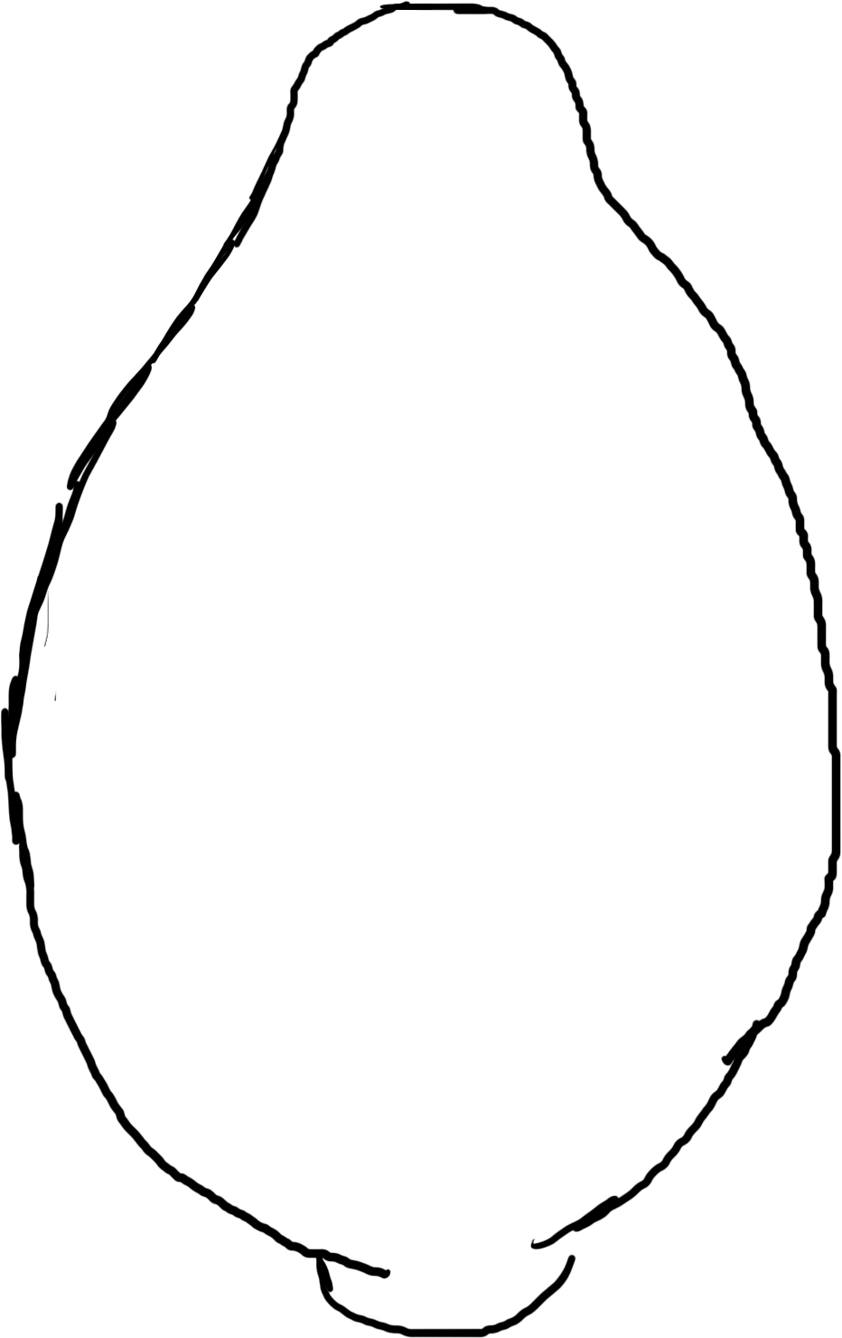
Growth phase; Vision, Limits and Helps; these are the anchor points of the child. The phase is represented by the seed, showing the potential and what is going to help or limit growth.

3.10 seed phase
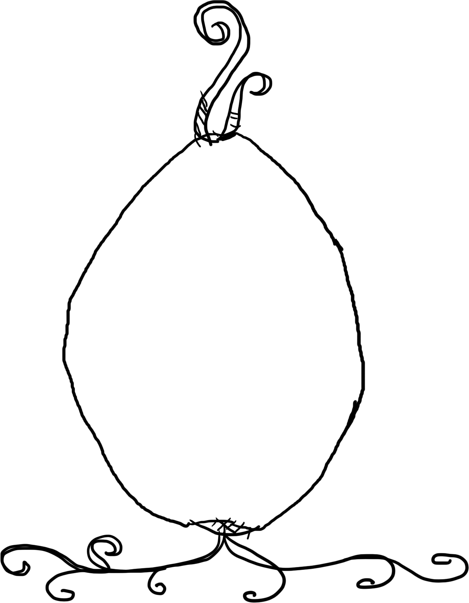
Exploratory phase: The next phase is of the apprentice, the young adult, learning, thinking and expressing. It is represented with the roots, reaching out, searching and exploring with Patterns, Ideas and Principles.

3.11 root phase
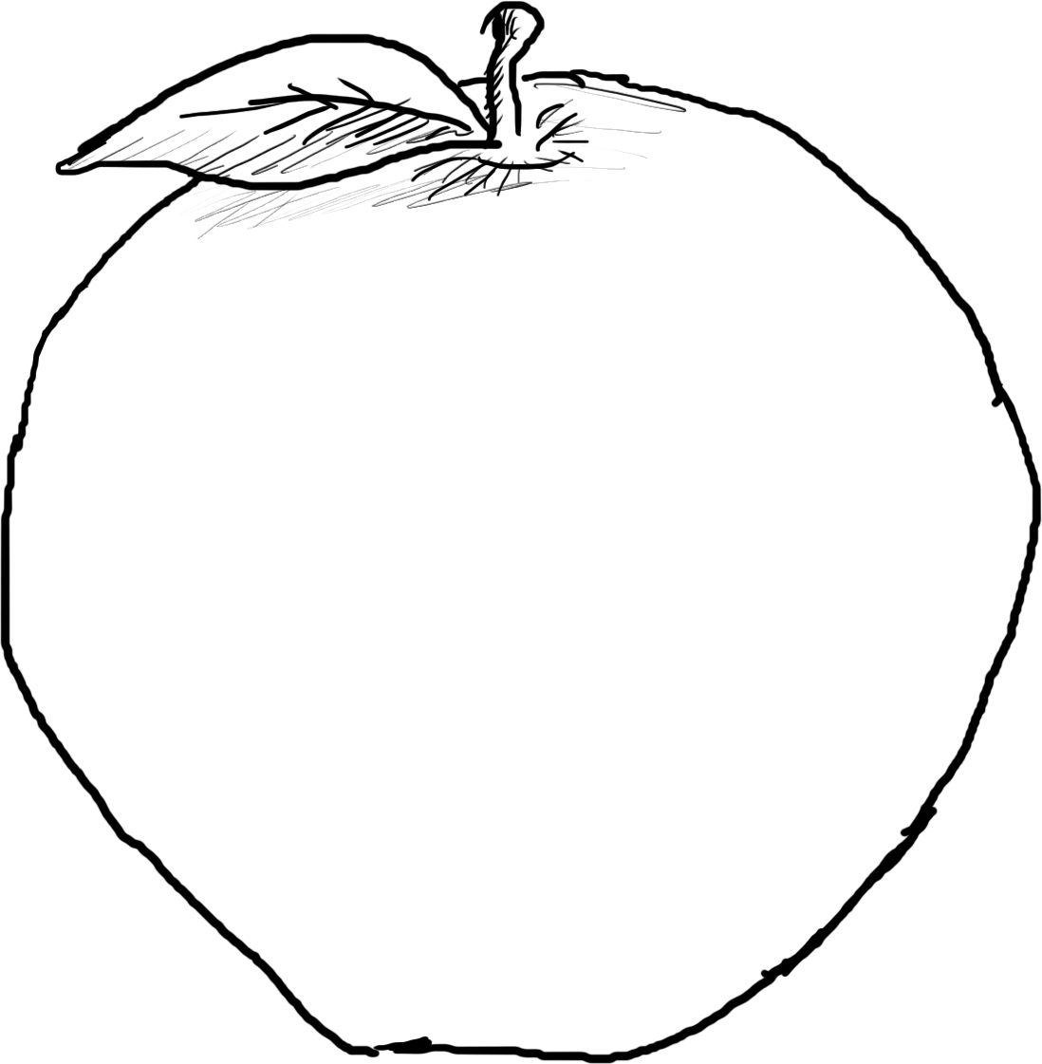
Productive phase: The adult stage of deciding, doing and producing is represented by the fruit, where we are looking for yields from our design in the anchor points of Integration, Action and Momentum.

3.12 fruit phase
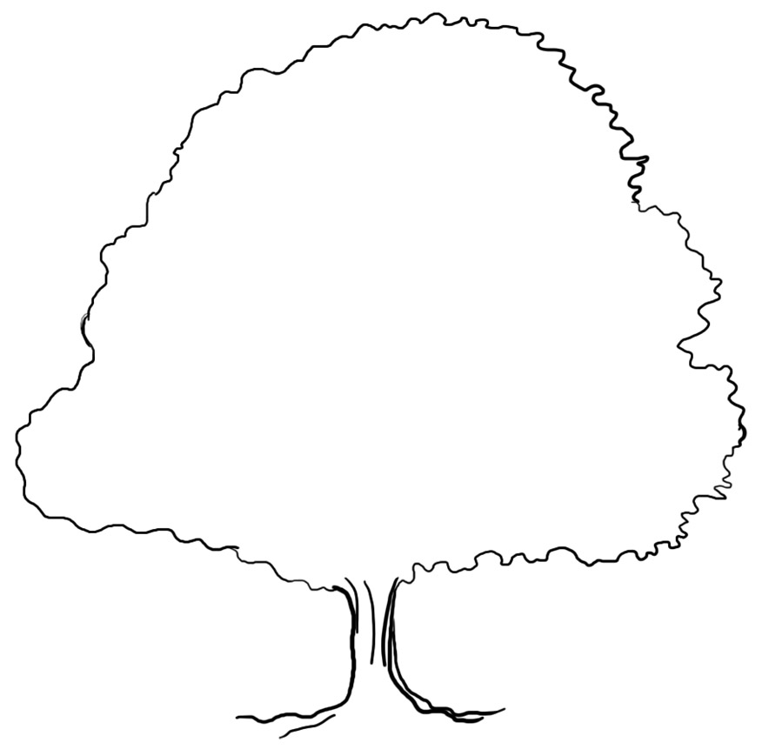
Reflective phase: Appreciation, Reflection and Pause are the introspective and insightful stages of the elder, represented by the mature tree.

3.13 mature tree phase

Design methods
As well as approaching each of the anchor points as a series of probing questions there are other tools we can use to gain insights. A lot of the activities are based on the anchor points, tailored to a specific issue. You will notice that some of them have more than one anchor point symbol with them showing how the anchor points can blend or follow on from each other. We will build up our toolbox of how to use the design web and then expand on each of these anchor points in the final part. We will look at how we can use different tools and methods when designing for ourselves, with other people, in larger systems or for other cultures in the following parts, alongside a real life design.

